Jesse James
Old West Revolver Shoot
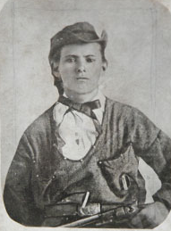
April 5, 2014

Registration 8 a.m. Shoot 9 a.m.
James Farm, 21216 Jesse James Farm Road, Kearney, MO 64060
816-736-8500

Test your skill on the favorite targets of Buck & Dingus, aka Frank & Jesse, and win a prize!

Cap & Ball Revolver Frontier Cartridge Revolver Replicas OK
Fixed sights and dueling stance only

$15 entry fee $5 special target Bob Ford

Jesse James Medallion prizes awarded for 1st, 2nd, & 3rd place

Sponsored by Clay County Parks, Recreation & Historic Sites and the Friends of the James Farm

